SOFTWARE REQUIREMENTS SPECIFICATION

for

Smart College Helpdesk
AI-Powered Management System

Prepared by: Arthi I (Erasmus student)
Host University: lodz university of technology

April 2026

Revision History
Name | Date | Reason for Changes | Version
Arthi I | 02/04/2026 | Initial version | 1.0
 | 13/04/2026 | Added use case diagram | 2.0
 | 20/04/2026 | Added class diagram | 3.0
 | 26/04/2026 | Added sequence diagram | 4.0
 | 20/04/2026 | Final overview | 5.0

1. Introduction

1.1. Purpose
This Software Requirements Specification (SRS) document defines the functional and non-functional requirements for the Smart College Helpdesk AI-Powered Management System, Version 1.0. The system is designed to digitize and automate the student complaint management workflow at Karunya Institute of Technology and Sciences. This document serves as the authoritative reference for developers, testers, and academic evaluators involved in the design, implementation, and validation of the system.

1.2. Document Conventions
This document follows the IEEE 830-1998 standard for Software Requirements Specifications. Requirements are numbered in the format REQ-X.Y where X is the feature number and Y is the sub-requirement index. Non-functional requirements are prefixed NF. Priority levels are designated High (H), Medium (M), and Low (L). Bold text denotes key terms. The word "shall" is used for mandatory requirements; "should" for recommended ones.

1.3. Intended Audience and Reading Suggestions
- Developers: Read Sections 3, 4, and 5 for technical specifications and design constraints.
- Testers: Focus on Section 5 (functional requirements) and Section 6 (performance/security).
- Academic Evaluators: Sections 1, 2, and Appendix (UML Diagrams) provide a holistic overview.
- System Administrators: Sections 2.4 and 4 cover operating environment and hardware/software interfaces.

1.4. Product Scope
The Smart College Helpdesk System is a web-based complaint management platform that enables students to submit grievances digitally, while an embedded AI engine automatically categorizes and prioritizes each complaint. Staff receive organized queues per department, and administrators gain oversight across the institution. The system eliminates manual triage, reduces resolution time, and improves student satisfaction through real-time status tracking and feedback collection.

1.5. References
- OpenAI. GPT-3.5 Turbo API Documentation. https://platform.openai.com/docs/
- Flask Documentation. https://flask.palletsprojects.com/
- SQLAlchemy ORM Documentation. https://www.sqlalchemy.org/
- IEEE Std 830-1998 — Recommended Practice for Software Requirements Specifications.
- Python Software Foundation. https://docs.python.org/3/
- Jurafsky & Martin. Speech and Language Processing. Pearson Education.

2. Overall Description

2.1. Product Perspective
The Smart College Helpdesk is a standalone, self-contained web application, not a replacement for any existing system, but a new platform filling a gap in institutional infrastructure. It interfaces with an external LLM API (GPT-3.5-turbo) for AI classification. The system operates as a three-tier application: a browser-based frontend, a Python Flask backend, and an SQLite relational database. It is intended to be deployed on an institutional server accessible over the campus network or via the internet.

2.2. Product Features
- AI-powered automatic complaint classification into 6 departments and 3 priority levels
- Role-based dashboards for Students, Staff, and Administrators
- Real-time complaint status tracking (Waiting → In Progress → Resolved)
- Post-resolution student feedback collection (5-star rating + comment)
- Secure authentication with Flask-Login and session management
- Responsive web interface for desktop and mobile compatibility
- Admin analytics: complaint trends, resolution times, departmental performance

2.3. User Classes and Characteristics
User Class | Description | Access Level
Student | Undergraduates/postgraduates submitting and tracking complaints. Non-technical users. | Submit, view own complaints, give feedback
Staff | Departmental staff handling assigned complaint queues. Moderate technical proficiency. | View dept queue, update status, respond
Administrator | IT/admin personnel overseeing the full system. High technical proficiency. | Full system access, reports, user management

2.4. Operating Environment
- Server OS: Ubuntu 20.04 LTS or Windows Server 2019
- Python: 3.8+, Flask 2.x, SQLAlchemy 1.4+
- Database: SQLite 3 (upgradable to PostgreSQL for production)
- Client: Any modern browser (Chrome 90+, Firefox 88+, Safari 14+, Edge 90+)
- Network: Requires internet connectivity for LLM API calls
- Hardware: Minimum 2GB RAM, 2-core CPU, 10GB storage for server deployment

2.5. Design and Implementation Constraints
- The AI classification module must use the OpenAI API; no on-premise ML training is performed.
- The database layer must use SQLAlchemy ORM to prevent SQL injection.
- Frontend must be rendered via Flask Jinja2 templates (no separate SPA framework).
- All form inputs must be validated server-side in addition to client-side.
- API keys must be stored as environment variables, never hardcoded.

2.6. User Documentation
- User Manual (PDF): Step-by-step guide for Students, Staff, and Administrators.
- In-app tooltips: Contextual help on the complaint submission form.
- README.md: Developer setup and deployment instructions.

2.7. Assumptions and Dependencies
- Assumption: The institution has stable internet connectivity for LLM API access.
- Assumption: Students have valid institutional email addresses for registration.
- Dependency: OpenAI API availability; system degrades to rule-based classification if unavailable.
- Dependency: Flask-Login library for session and authentication management.

3. System Features

3.1. Student Complaint Submission
Allows authenticated students to submit complaints through a structured web form. The system collects the complaint text, automatically routes it to the correct department, and assigns a priority level.

3.2. AI-Based Classification Engine
An embedded AI engine processes complaint text using GPT-3.5-turbo via prompt engineering, returning a structured JSON response containing department category and urgency priority.

3.3. Role-Based Dashboards
Three distinct dashboards — Student, Staff, and Administrator — provide role-specific views, functions, and permissions enforced through Flask-Login RBAC.

3.4. Complaint Status Tracking
Students can monitor the real-time lifecycle of their complaints (Waiting, In Progress, Resolved) from their dashboard without needing to contact staff.

3.5. Feedback and Ratings
Upon complaint resolution, the student is prompted to submit a 1–5 star rating and optional comment, closing the service loop and enabling quality measurement.

4. External Interface Requirements

4.1. User Interfaces Overview
The system provides a browser-based GUI rendered through Flask Jinja2 templates with HTML5/CSS3. Key screens include:
- Login / Registration Page: Email + password form with validation messages.
- Student Dashboard: List of submitted complaints with status badges, a 'New Complaint' button.
- Complaint Submission Form: Multi-line text area, submit button; no manual category selection required.
- Staff Queue View: Filterable list of assigned complaints with status update controls.
- Admin Panel: System-wide complaint table, user management, and summary statistics.
- Feedback Page: Star-rating widget + text field, displayed post-resolution.
All pages share a responsive navigation bar. Error messages appear as inline form validation or flash banners. Minimum supported viewport: 360px width (mobile).

4.2. Hardware Interfaces
The system runs on a standard web server with no specialized hardware requirements. Client devices require only a modern web browser. No direct hardware interface beyond TCP/IP networking.

4.3. Software Interfaces
Component | Version | Purpose
Python Flask | 2.x | Web framework, routing, session management
SQLAlchemy ORM | 1.4+ | Database abstraction, injection prevention
SQLite | 3.x | Persistent data storage
OpenAI API | GPT-3.5-turbo | Complaint classification and prioritization
Flask-Login | 0.6+ | Authentication, RBAC session management
Jinja2 | 3.x | HTML templating with XSS auto-escape

5. System Features / Modules

5.1. Student Complaint Submission

5.1.1 Description and Priority
This module handles the end-to-end process of a student submitting a new complaint. It is the primary entry point into the system and is classified as High Priority.

5.1.2 Stimulus / Response Sequences
Stimulus | Response
Student submits complaint form | System validates input, triggers AI classification, stores complaint, displays tracking ID
Complaint text is empty | System displays inline error; form is not submitted
API call fails | System falls back to keyword-based classification; complaint is still stored

5.1.3 Functional Requirements
ID | Requirement
REQ-1.1 | Upon authenticated student submitting a complaint form, the system shall validate that the complaint text is non-empty and between 10 and 2000 characters.
REQ-1.2 | Upon successful validation, the system shall send the complaint text to the AIClassifier module within 500 milliseconds.
REQ-1.3 | The system shall store the complaint with its assigned category, priority, and timestamp in the database.
REQ-1.4 | The system shall display a unique complaint ID and current status to the student upon successful submission.
REQ-1.5 | Upon API failure, the system shall apply keyword-based fallback classification and log the error.

5.2. AI Classification Engine

5.2.1 Description and Priority
The AI module uses GPT-3.5-turbo via prompt engineering with few-shot examples to classify complaints into departments and assign priorities. Priority: High.

5.2.2 Stimulus / Response Sequences
Stimulus | Response
Backend calls classify(text) | AIClassifier builds prompt, calls API, parses JSON, returns {category, priority}
API returns malformed JSON | AIClassifier throws exception; backend applies fallback rule-based classification

5.2.3 Functional Requirements
ID | Requirement
REQ-2.1 | The AIClassifier shall classify complaint text into one of six categories: Finance, Academic Support, Technical Support, Hostel Management, Library Services, General Queries.
REQ-2.2 | The AIClassifier shall assign one of three priority levels: High, Medium, or Low, based on urgency keywords.
REQ-2.3 | The AIClassifier shall use few-shot prompting with at least two examples per category to improve accuracy.
REQ-2.4 | The AIClassifier shall return a structured JSON response containing 'category' and 'priority' fields.
REQ-2.5 | Classification shall complete within 2 seconds under normal API response conditions.

5.3. Role-Based Access Control (RBAC)

5.3.1 Description and Priority
Implements three-role access using Flask-Login: Student, Staff, Administrator. Each role has defined permissions enforced at the route level. Priority: High.

5.3.2 Functional Requirements
ID | Requirement
REQ-3.1 | The system shall authenticate users using email and hashed password; plain-text passwords shall never be stored.
REQ-3.2 | Upon login, the system shall redirect users to their role-specific dashboard.
REQ-3.3 | Students shall only be permitted to view their own submitted complaints.
REQ-3.4 | Staff shall only be permitted to view and update complaints assigned to their department.
REQ-3.5 | Administrators shall have read and write access to all complaints and user records.
REQ-3.6 | Upon unauthorized access attempt, the system shall return HTTP 403 and redirect to the login page.

5.4. Complaint Status Tracking

5.4.1 Description and Priority
Students can track complaint lifecycle in real time. Status transitions: Waiting → In Progress → Resolved. Priority: Medium.

5.4.2 Functional Requirements
ID | Requirement
REQ-4.1 | The system shall display the current status of each complaint on the student dashboard.
REQ-4.2 | Staff shall be able to update complaint status to 'In Progress' or 'Resolved'.
REQ-4.3 | Upon status change to 'Resolved', the system shall unlock the feedback submission form for the relevant student.
REQ-4.4 | Status transitions shall be logged with timestamp and staff ID.

5.5. Feedback Collection

5.5.1 Description and Priority
After complaint resolution, the student submits a 1–5 star rating and optional comment. This data is used for service quality assessment. Priority: Low.

5.5.2 Functional Requirements
ID | Requirement
REQ-5.1 | The system shall present a feedback form to the student only after the complaint status is set to 'Resolved'.
REQ-5.2 | The feedback form shall accept a mandatory star rating (1–5) and an optional comment (max 500 chars).
REQ-5.3 | Feedback shall be stored in the database linked to the complaint ID and student ID.
REQ-5.4 | Administrators shall be able to view aggregate feedback statistics per department.

6. Non-Functional Requirements

6.1. Performance
ID | Requirement
NF-1.1 | Complaint submission processing (excluding AI API latency) shall complete within 2 seconds.
NF-1.2 | Dashboard page load time shall not exceed 1 second for datasets of up to 1,000 complaints.
NF-1.3 | AI classification (end-to-end including API call) shall complete within 3 seconds under normal network conditions.
NF-1.4 | The system shall support at least 50 concurrent user sessions without degradation.

6.2. Security
ID | Requirement
NF-2.1 | All database queries shall be executed through SQLAlchemy ORM to prevent SQL injection.
NF-2.2 | All HTML output shall be auto-escaped via Jinja2 to prevent Cross-Site Scripting (XSS).
NF-2.3 | User passwords shall be stored using bcrypt hashing with a minimum cost factor of 12.
NF-2.4 | API keys and secrets shall be stored as environment variables and shall never appear in source code.
NF-2.5 | Session tokens shall expire after 30 minutes of inactivity.

6.3. Reliability
ID | Requirement
NF-3.1 | The system shall maintain 99% uptime during academic term periods.
NF-3.2 | On AI API failure, the system shall fall back to rule-based classification without crashing.

6.4. Maintainability
ID | Requirement
NF-4.1 | The codebase shall follow a modular MVC structure separating routes, models, and templates.
NF-4.2 | All AI-related code shall be encapsulated in a standalone AIClassifier module to allow easy replacement.

Appendix A — Use Case Diagram

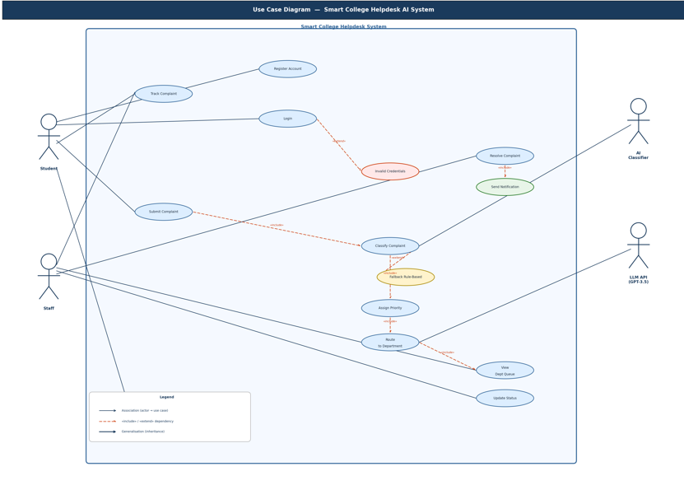

Figure A.1 illustrates the use case diagram for the Smart College Helpdesk AI System, depicting the interactions between system actors and the functional use cases supported by the platform.

Actors
The system involves four actors:
- Student — the primary end-user who registers, logs in, submits and tracks complaints, and optionally provides feedback.
- Staff — college department personnel who view their department's complaint queue, update complaint statuses, and resolve complaints.
- AI Classifier — an automated system actor responsible for classifying incoming complaints by category.
- LLM API (GPT-3.5) — an external AI service actor that handles intelligent routing of complaints to the appropriate department.

Use Cases and Relationships
Authentication Flow: Students begin by registering an account and logging in. If invalid credentials are entered, the system extends to an Invalid Credentials notification use case, informing the user of the authentication failure.
Complaint Submission and Classification: Upon login, a student can submit a complaint. This triggers an automatic Classify Complaint use case (via an «include» dependency), handled by the AI Classifier actor. If the classifier is unable to determine a category with sufficient confidence, the system extends to a Fallback Rule-Based classification mechanism as a contingency. Classification always includes an Assign Priority step, which in turn includes Route to Department — delegated to the LLM API (GPT-3.5) — ensuring complaints reach the correct department queue.
Complaint Tracking: Both students and staff can track the status of complaints. Staff additionally have access to their View Department Queue, allowing them to monitor all complaints routed to their department.
Resolution Workflow: Staff can Update Status on active complaints and Resolve Complaint once addressed. Resolution automatically triggers a Send Notification use case (via «include»), informing the relevant student of the outcome.
Feedback (Optional): Students may optionally Submit Feedback following the resolution of a complaint. This is modelled as an «extend» relationship, indicating it is not a mandatory step in the workflow but an available action.

Notation Summary
The diagram follows standard UML use case notation: solid lines represent associations between actors and use cases; dashed arrows denote «include» (mandatory dependency) and «extend» (conditional or optional behaviour) relationships; bold arrows represent generalisation/inheritance.

Appendix B: UML Class Diagram

The following UML Class Diagram illustrates the five core classes of the Smart College Helpdesk system, incorporating key OOP relationships: Inheritance (Student, Staff, Administrator extend User), Composition (AIClassifier is created and owned by the Complaint submission process), Aggregation (Feedback exists independently but is associated with a Complaint), and Associations (Student submits Complaints; Staff manages Complaints; Department categorizes Complaints).

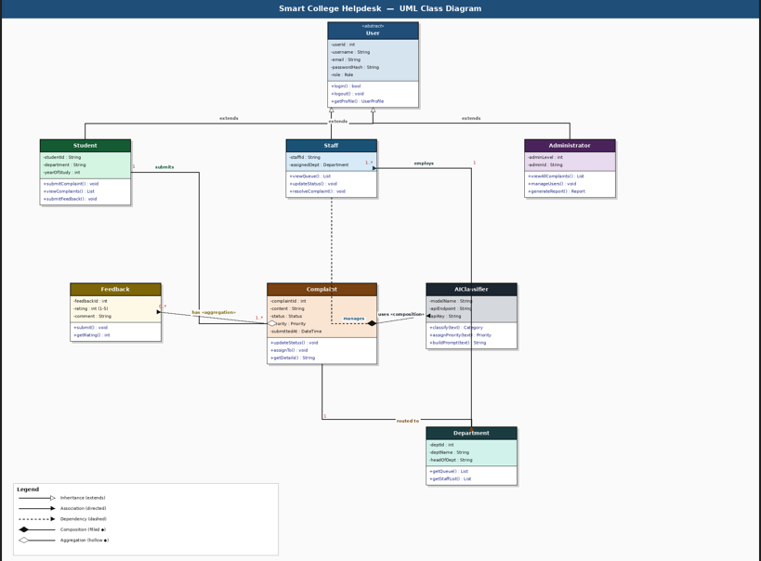

Class | Role | Key Relationships
User (abstract) | Base entity | Generalization parent of Student, Staff, Administrator
Student | Complaint creator | Inherits User; Association → submits Complaint (1..*)
Staff | Queue handler | Inherits User; Dependency → manages Complaint
Administrator | System overseer | Inherits User; full system access
Complaint | Core entity | Aggregation ← Feedback; Composition → AIClassifier uses; Association → Department
AIClassifier | AI engine | Composition with Complaint submission; calls LLM API
Feedback | Rating entity | Aggregation linked to Complaint; submitted by Student
Department | Routing entity | Association to Staff (belongs-to) and Complaint (routed-to)

Appendix C: Sequence Diagram – Complaint Submission Flow
The sequence diagram below depicts the complete interaction flow when a student submits a complaint: from form submission, through the Flask backend, AI classification, database storage, and staff notification.

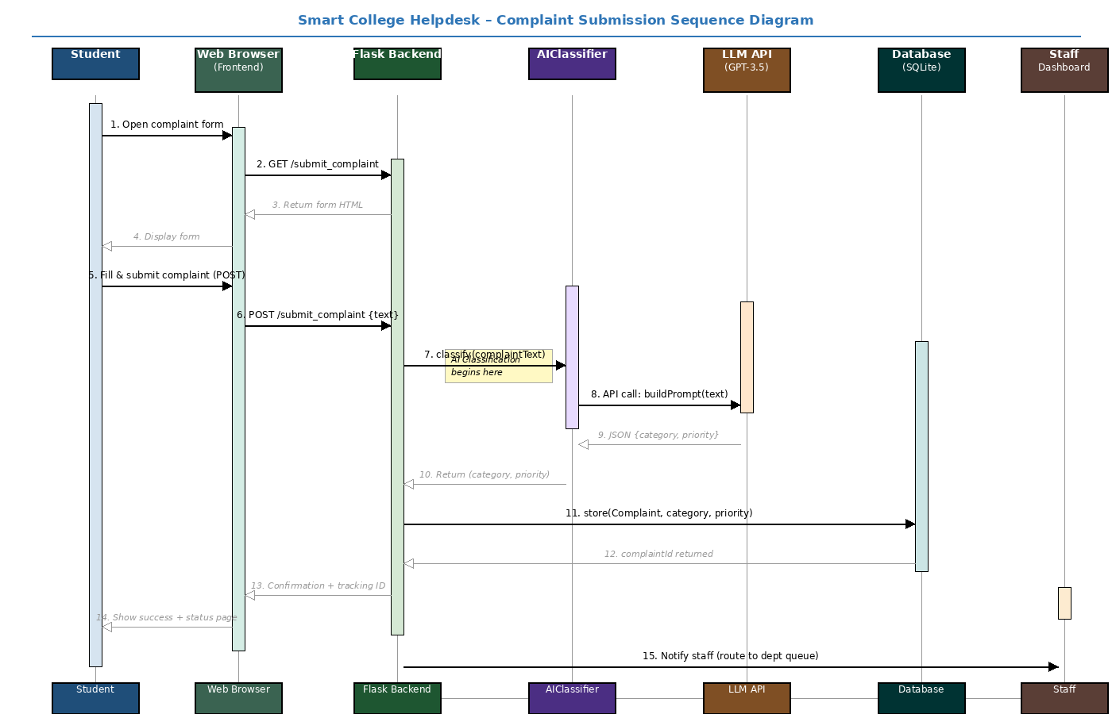

Step | Actor | Description
1–4 | Student ↔ Frontend | Student opens the complaint form; frontend serves HTML via GET request
5–6 | Student → Backend | Student submits complaint text via HTTP POST
7–10 | Backend ↔ AIClassifier ↔ LLM API | Backend invokes AIClassifier; prompt is constructed and sent to GPT-3.5-turbo; JSON response is parsed
11–12 | Backend ↔ Database | Classified complaint is persisted to SQLite with category, priority, and timestamp
13–14 | Backend → Student | Confirmation page with complaint tracking ID is returned to the student
15–16 | Backend → Staff Dashboard | Complaint is routed to the relevant department staff queue

Appendix C: Design Notes – OOP Relationships
The following table summarizes all UML relationships implemented in the class design, as required by the evaluation criteria.

Relationship Type | From | To | Explanation
Inheritance (is-a) | Student, Staff, Admin | User | All three user types extend the abstract User class, sharing login/profile behaviour
Composition (owns) | Complaint Submission | AIClassifier | AIClassifier is instantiated and owned within the complaint submission process; it does not exist independently
Aggregation (has) | Complaint | Feedback | A Complaint can have zero or many Feedback objects; Feedback can exist independently in the database
Association (submits) | Student | Complaint | A Student submits one or more Complaints; Student and Complaint have independent lifecycles
Association (manages) | Staff | Complaint | Staff members update and resolve Complaints assigned to their department
Association (routed to) | Complaint | Department | Each Complaint is classified and routed to exactly one Department
Association (belongs to) | Staff | Department | Each Staff member belongs to one Department, which determines their complaint queue

